**File:** Tihomir_Lidanski_27_dafd44.rb

Task:

Develop a program named FirstName_LastName_ClassNumber_dafd44.rb

1. you are given two arguments for a folders with files;

1.1 if there are other arguments they should be discarded;

2. Find all the files from both folders that have exactly 7 digits from 0 to 9 in their names excluding extension. If there are duplicates the file must be written only once.;

3. Calculate the length of their names (including extensions) divided by 2 rounded to the smalles number;

4. Sort the result by File name ;

5. Produce a result in CSV format named result.csv:

File1,3

File2,4

...

FileN,3

Code:

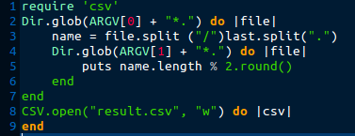

Errors:

* Program will write duplicates files several time
* Program code just missing

New code:

